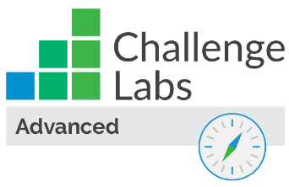

Configure Monitoring by Using Azure Monitor

Understand the scenario

You are an Azure® administrator responsible for your organization’s Azure environment. You need to review information about your Azure resources and applications by using Azure Monitor. First, you will view the Azure activity log. Next, you will create an Azure alert. Finally, you will review Azure Monitor options.

Understand your environment

You will be using a pre-created Azure account that contains a resource group named AZ900RGlod26435233, a storage account named sa26435233, and a Windows® virtual machine named VM1.

# **View the Azure activity log by using Azure Monitor**

* Sign in to the Azure portal

Select the Copy to clipboard icon to copy the text string to the clipboard.

A cloud slice is a portion of an Azure subscription that has been assigned to a user account that was provisioned for you. This provides you with transient, just-enough access to Azure so that you can learn the concepts in this challenge.

You have been granted subscription-level permissions necessary to perform this challenge. As a result, you may be able to see other resource groups and resources; however, you will only have permission to create and manage resources in the resource group AZ900RGlod26435233.

* View the Azure activity log for the **AZ900RGlod26435233** resource group.

Expand this hint for guidance on viewing an activity log for a resource group.

* + In the Azure portal, in the upper-left corner, select the **Show portal menu** icon.



* + On the Azure portal menu, select **Monitor**.

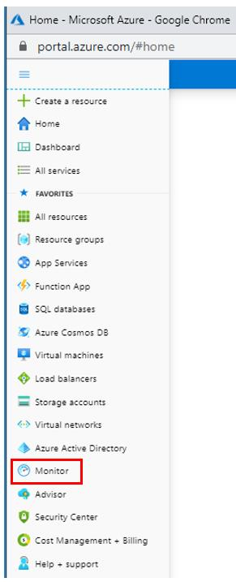

* + On the Monitor resource menu, select **Activity log**.

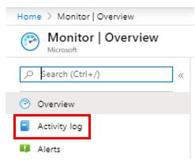

* + On the Activity log filter page, select **Add Filter**.



* + Select **All resource groups**, and then select **AZ900RGlod26435233**.

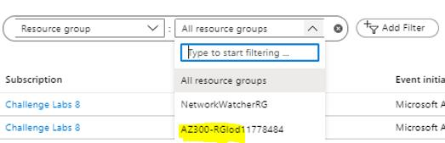

You can use [Azure Monitor](https://docs.microsoft.com/en-us/azure/azure-monitor/overview) to gather information about your Azure resources and applications in order to proactively identify issues that might be affecting them.

You can use the Azure Monitor [activity log](https://docs.microsoft.com/en-us/azure/azure-resource-manager/management/view-activity-logs" \t "_blank) page to view all activities that took place in the Azure management plane of your subscription during the past 90 days.

* View the change history for the **Update Storage Account Create** operation in the **AZ900RGlod26435233** Azure activity log.

Expand this hint for guidance on viewing the change history of an activity log operation.

* + On the Activity log page, select **Update Storage Account Create**.

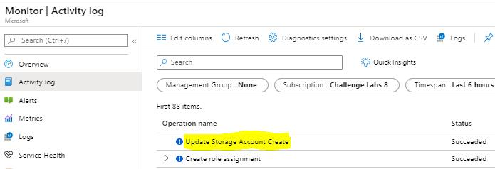

* + On the Update Storage Account Create page, select **Change history (Preview)**.

Every entry in the Azure activity log will display a Summary tab that provides three fields of information—Operation name, Time stamp, and Event initiated by—and a JSON tab that provides details about the operation. For operations that involve a resource that can be updated, you will also see a Change history (Preview) tab that shows the changes that were made to the resource and who made the changes.

## Check your work

* Confirm that you viewed the Azure Monitor activity log page.

# **Create an Azure alert by using Azure Monitor**

* Create an action group named Virtual Machine Admins by using the **AZ900RGlod26435233** resource group, a short name of VM Admins, and an action named VM Shutdown that will send an email to your personal email account when the action is triggered.

Expand this hint for guidance on creating an action group.

* + On the Monitor resource menu, select **Alerts**, and then on the command bar, select **Manage actions**.

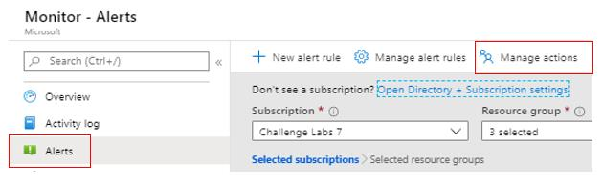

* + Select **Add action group**.
  + On the Add action group blade, in Action group name, enter Virtual Machine Admins, and then in Display name, enter VM Admins.
  + In Resource group, select **AZ900RGlod26435233**.
  + Select **Next:notifications**.
  + In Notification type, select **Email/SMS/Push/Voice**, and enter VM Shutdown in Name.
  + On the Email/SMS/Push/Voice blade, select **Email**, and then enter your personal email address.
  + Select **OK** to return to the Manage actions blade, select **Review + create**, and the select **Create** to create the action group, and then close the **Manage actions** page.

You can create an action group by using the [Azure portal](https://docs.microsoft.com/en-us/azure/azure-monitor/platform/action-groups), the Azure PowerShell® [Set-AzActionGroup](https://docs.microsoft.com/en-us/powershell/module/az.monitor/set-azactiongroup?view=azps-3.7.0) cmdlet, or the Azure CLI 2.0 [az monitor action-group create](https://docs.microsoft.com/en-us/cli/azure/monitor/action-group?view=azure-cli-latest#az-monitor-action-group-create) command.

You can use action groups to configure preferences for actions that you want Azure to take when a specific monitored event occurs.

* Verify that your personal email address has been added to the VM Shutdown action group.

Expand this hint for guidance on verifying action group membership.

* + Open your personal email, and then verify that you received an email similar to the following screenshot:

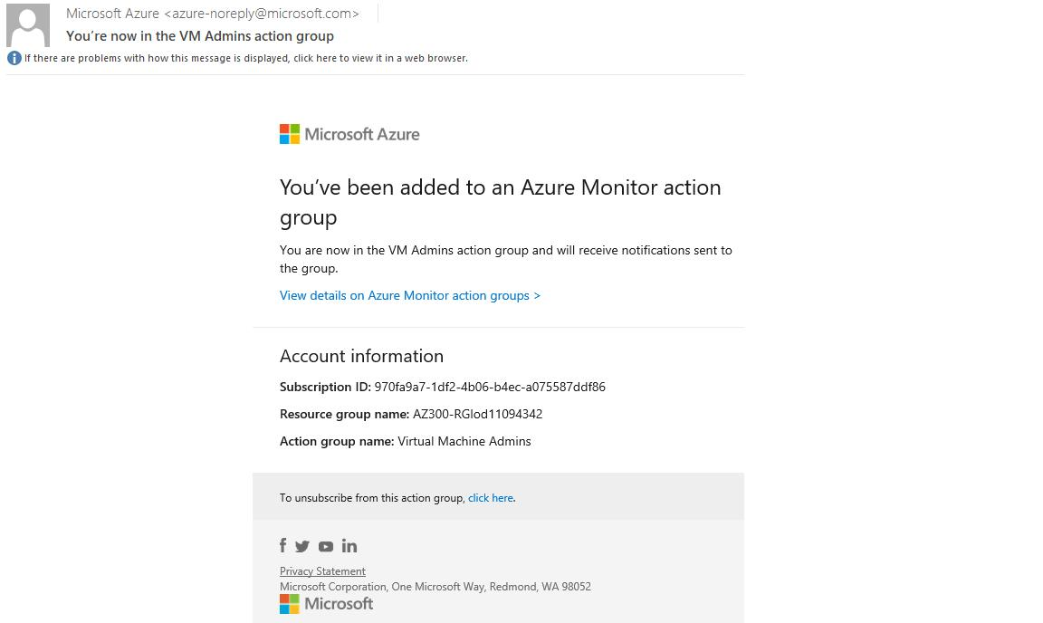

* Create an activity log alert rule named VM1 Shutdown that will send an **Informational** alert with the description VM1 has shut down to the **Virtual Machine Admins** action group when the **Deallocate Virtual Machine (Microsoft.Computer/virtualMachines)** signal is triggered.

Expand this hint for guidance on creating an activity log alert rule.

* + On the Alerts resource menu, on the command bar, select **New alert rule**.
  + In RESOURCE, select **Select**.
  + On the Select a resource blade, in Type to start filtering, enter Virtual, and then select **Virtual machines**.
  + Ensure that **AZ900RGlod26435233** is expanded, select **VM1**, and then select **Done**.
  + In CONDITION, select **Add**.
  + In Signal type, select **Activity Log**, and then in Monitor service, select **Activity Log - Administrative**.

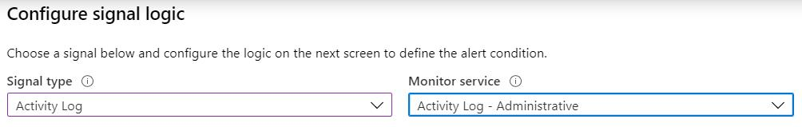

* + Select **Deallocate Virtual Machine (Microsoft.Computer/virtualMachines)**.
  + In Alert logic, in Event Level, select **Informational**, in Status, select **Succeeded**, and then select **Done**.

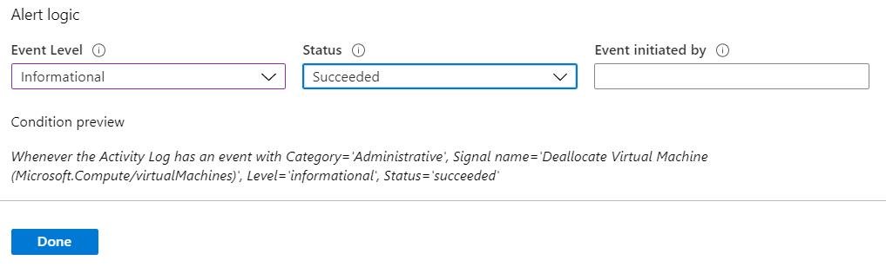

* + In ACTIONS GROUPS (optional), select **Add**.
  + Select **Virtual Machine Admins**, and then select **Select**.
  + In ALERT DETAILS, in Alert rule name, enter VM1 Shutdown, and then in Description, enter VM1 has shut down.
  + Select **Create alert rule**.

You can create an [activity log alert rule](https://docs.microsoft.com/en-us/azure/azure-monitor/platform/alerts-activity-log" \t "_blank) by using the Azure portal, the Azure PowerShell [Set-AzActivityLogAlert](https://docs.microsoft.com/en-us/powershell/module/az.monitor/set-azactivitylogalert?view=azps-3.7.0) cmdlet, or the Azure CLI 2.0 [az monitor alert create](https://docs.microsoft.com/en-us/cli/azure/monitor/alert?view=azure-cli-latest#az-monitor-alert-create) command.

An alert rule has three parts:

* + **Resource** - Select the target(s) you want to monitor.
  + **Condition** - Specify the logic that will fire the alert.
  + **Actions** - Configure the actions to take when the alert fires (notifications via email, text messages, web hooks, runbooks, functions, logic apps, or integration with external IT Service Management (ITSM) solutions).

The signal types that are available for monitoring vary based on the selected targets. The signal types may be metrics, log search queries, or activity logs.

Action rules allow you to configure an action across resources in a specific scope. With action rules, you can set granular control of notifications or suppression, and you can run diagnostics for quick troubleshooting.

* Verify that the alert rule named **VM1 Shutdown** exists and that the status is **enabled**.

Expand this hint for guidance on viewing an alert rule.

* + On the Alerts resource menu, on the command bar, select **Manage alert rules**.
  + On the Rules page, verify that the **VM1 Shutdown** rule exists and that the status is **enabled**.

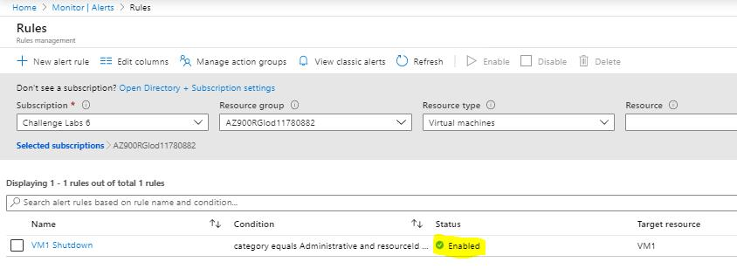

* + Close the **Rules** page.

## Check your work

* Confirm that you created an action group named Virtual Machine Admins that contains an action named VM Shutdown.
* Confirm that you configured the VM Shutdown action to send an email to your personal email account when the action is triggered.
* Confirm that you created an activity log alert rule named VM1 Shutdown that will send an email to the Virtual Machine Admins alert group when the VM1 virtual machine shuts down.

# **Explore the Azure Monitor resource menu**

* View the contents of the **Metrics** page on the Azure Monitor resource menu, and then view metrics for **VM1**.

Expand this hint for guidance on viewing a resource menu page.

* + On the Monitor resource menu, select **Metrics**, and then view the available options.
  + On the Select a scope page, select **VM1**, and then select **Apply**.

You will not see any data on the Metrics page because you have not configured VM1 for diagnostics and data collection.

You can use [Azure Metrics](https://docs.microsoft.com/en-us/azure/azure-monitor/platform/data-platform-metrics) to analyze, visualize, alert, automate, export, retrieve, and archive metric data.

* View the contents of the **Logs** page on the Azure Monitor resource menu.

If prompted to select a scope, select the **AZ900RGlod26435233** resource group.

In this challenge, you will not be able to run a query because a [Log Analytics workspace](https://docs.microsoft.com/en-us/azure/azure-monitor/learn/quick-create-workspace) has not been created for your subscription.

[Azure log](https://docs.microsoft.com/en-us/azure/azure-monitor/platform/data-platform-logs) data is stored in a Log Analytics workspace. You can use the Logs page on the Azure Monitor resource menu to [query Azure logs](https://docs.microsoft.com/en-us/azure/azure-monitor/log-query/get-started-queries" \t "_blank).

* View each of the remaining Azure Monitor resource menu pages.

The Insights section of the Azure Monitor resource menu provides charts and filters for various resources—including applications, containers, and networks.

In the Settings section of the resource menu, the Diagnostic settings page provides quick access to information for Azure resources that have their [diagnostics settings enabled](https://docs.microsoft.com/en-us/azure/azure-monitor/platform/diagnostic-settings" \t "_blank). You can configure diagnostics settings on this page of Azure Monitor, or from the Diagnostic settings menu of an individual Azure resource.

## Check your work

* Confirm that you viewed Azure Monitor Metrics options.

# **Summary**

Congratulations, you have completed the **Configure Monitoring by Using Azure Monitor** challenge.

You have accomplished the following:

* Viewed the Azure activity log by using Azure Monitor.
* Created an Azure alert by using Azure Monitor.
* Viewed Azure Monitor metrics and logs.